# CS 255 System Design Document Template

This template lays out all the different sections that you need to complete for Project Two. Each section has guidance to prompt your thinking. You will need to continually reference the interview transcript as you work to make sure that you are addressing your client’s needs. There is no required length for the final document. Instead the goal is to complete each section based on what your client’s needs are. Remove this note when you are finished, and replace all bracketed text with the relevant information.

## UML Diagrams

### UML Use Case Diagram

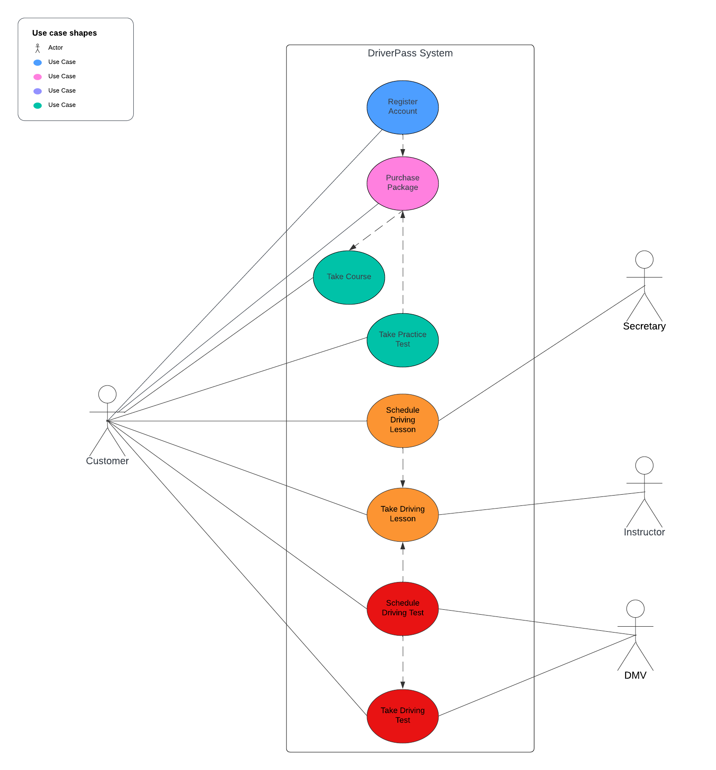

### UML Activity Diagrams

Diagram 1: Account Creation

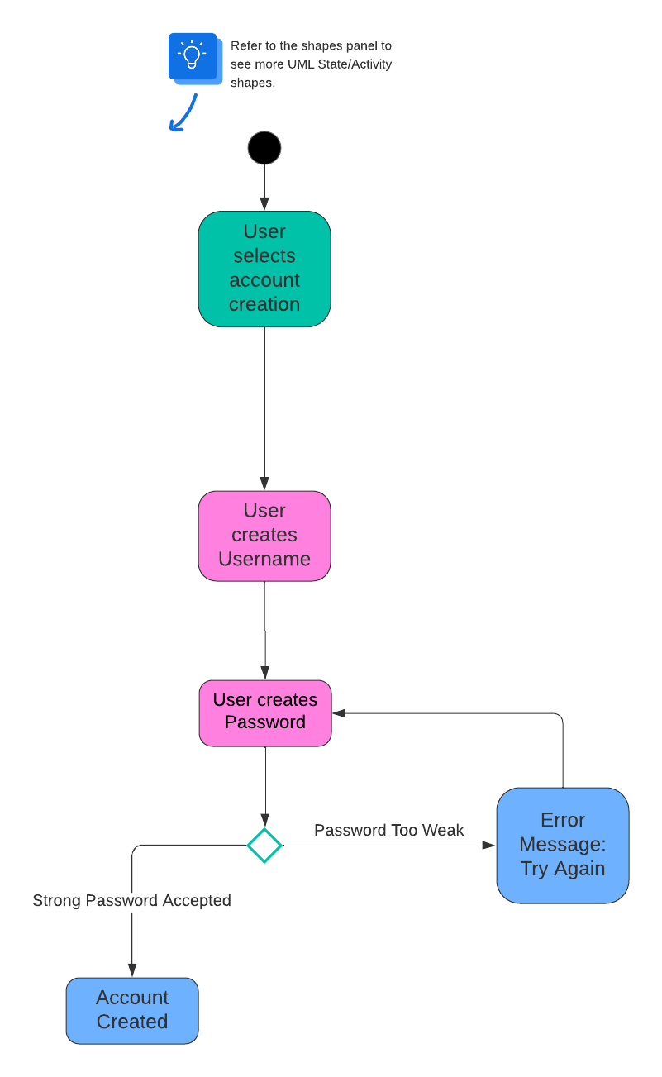

Diagram 2: Scheduling a Driving Lesson

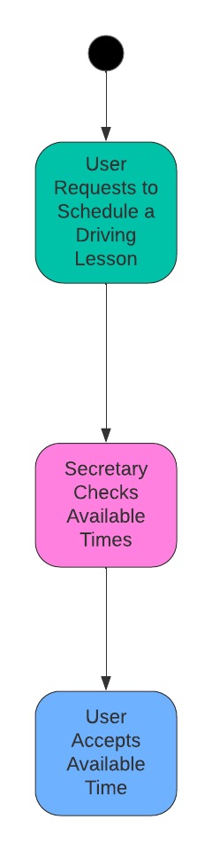

### UML Sequence Diagram

Account Creation

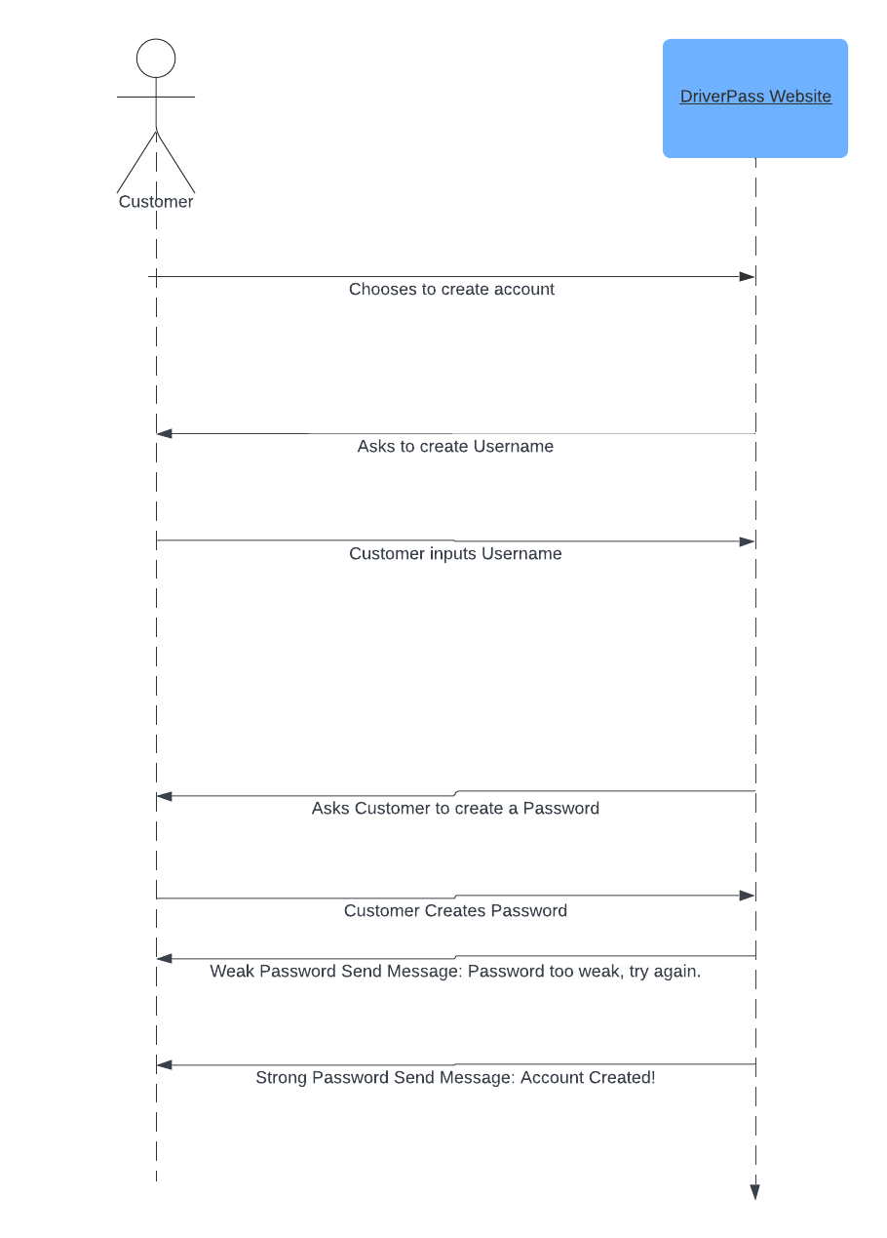

### UML Class Diagram

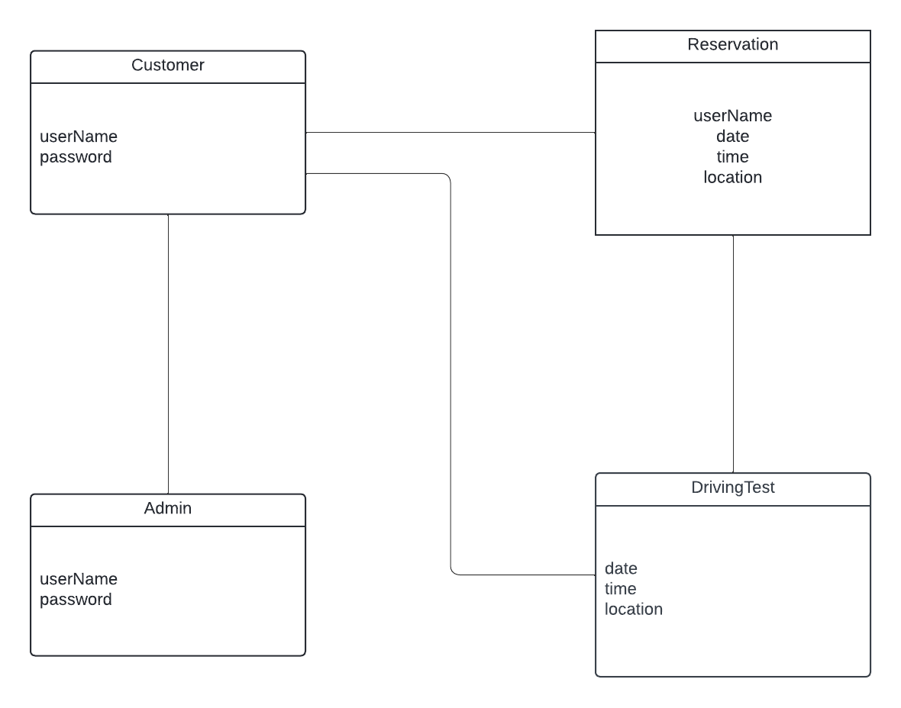

## Technical Requirements

The technical requirements would include a website, cloud access for the website, and the website would allow the customer to create an account and make reservations for driving tests. There will also be software that would allow the website to have access to the DMV in order to update new regulations and also laws that have changed. The system would also require vehicles in order to carry out the driving tests.